Social Media Plan & Posts for Library Partners

Facebook Posts
Link to include at the end of EVERY post: http://moocs.wisc.edu/

Post Number | Image | Text
Post #1  Post date:  Week of 9/21 |  | Your health, your family’s health, your neighbor’s health – what does climate change have to do with it? Join the UW-Madison MOOC “Climate Change Policy and Public Health” starting November 9th to learn how public health can be protected when we protect the environment and the climate. We will be hosting discussion sessions {FILL IN DATE AND TIME} http://moocs.wisc.edu/
Post #2  Post date:  Week of 9/28 | 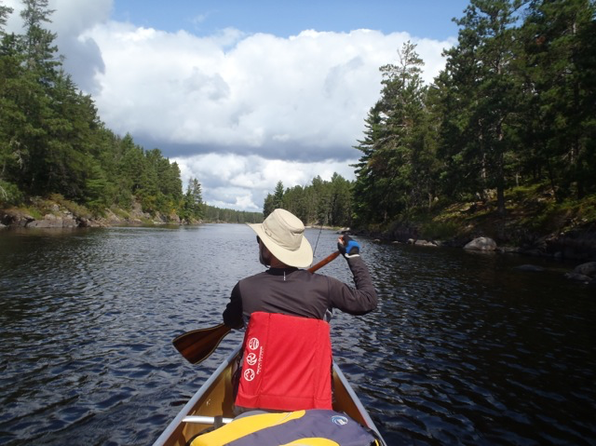 | Join Professor Jonathan Patz, Director of the Global Health Institute, a lead author for the Intergovernmental Panel on Climate Change (IPCC), winner of the 2007 Nobel Peace Prize, and your instructor — here, canoeing this summer — in the UW-Madison MOOC “Climate Change Policy and Public Health” starting November 9th! We will be hosting discussion sessions {FILL IN DATE AND TIME}…http://moocs.wisc.edu/
Post #3  Post date:  Week of 10/5 | 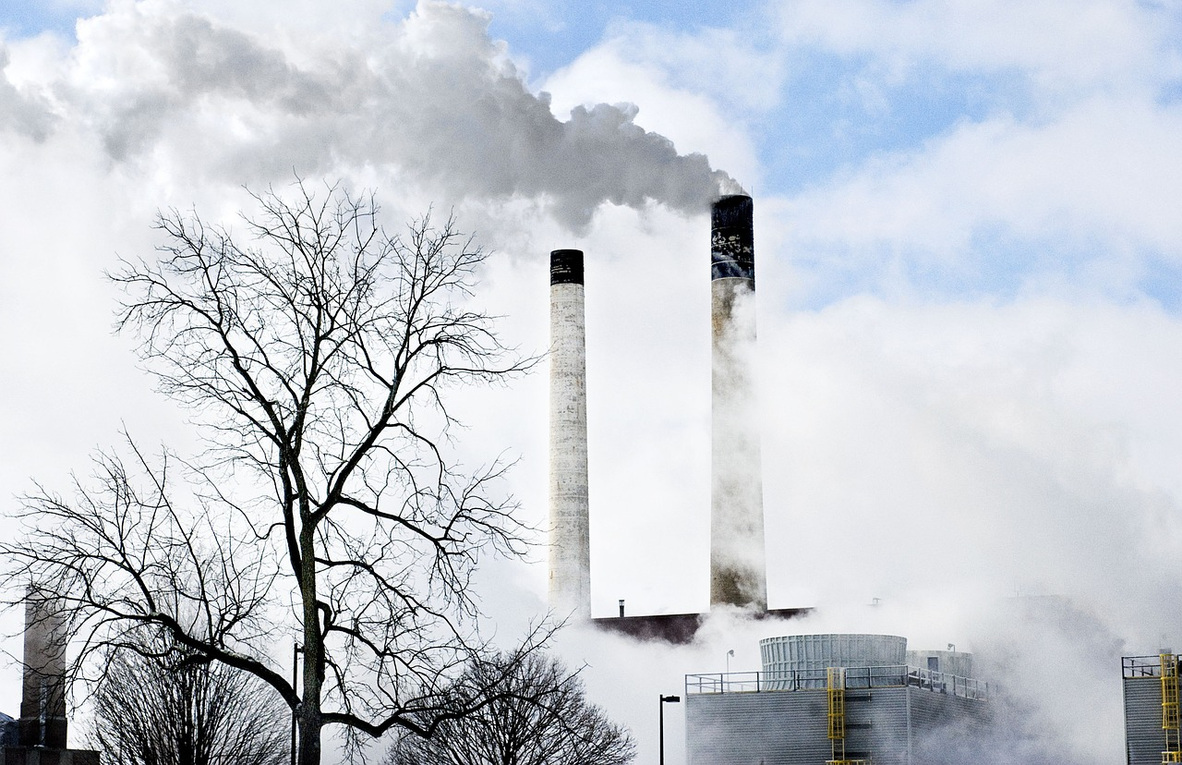 | Which of the following does climate change NOT impact? *Infectious diseases *Allergies *Respiratory disorders *Hunger *Heat stroke Answer: Climate change impacts ALL of them. Join the UW-Madison MOOC “Climate Change Policy and Public Health” starting November 9th to learn more. We will be hosting discussion sessions {FILL IN DATE AND TIME} http://moocs.wisc.edu/
Post #4  Post date:  Week of 10/12 | 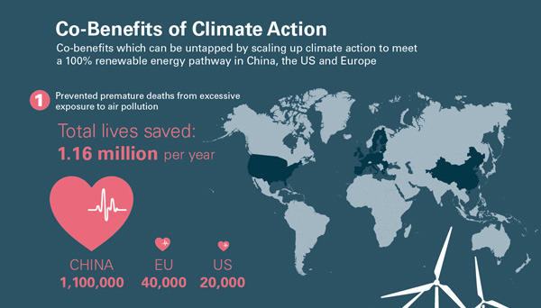 | Use of renewable energy = protecting climate AND saving lives. Sign up for the UW-Madison MOOC “Climate Change Policy and Public Health” starting November 9th to learn more! We will be hosting discussion sessions {FILL IN DATE AND TIME} http://moocs.wisc.edu/
Post #5  Post date:  Week of 10/19 | 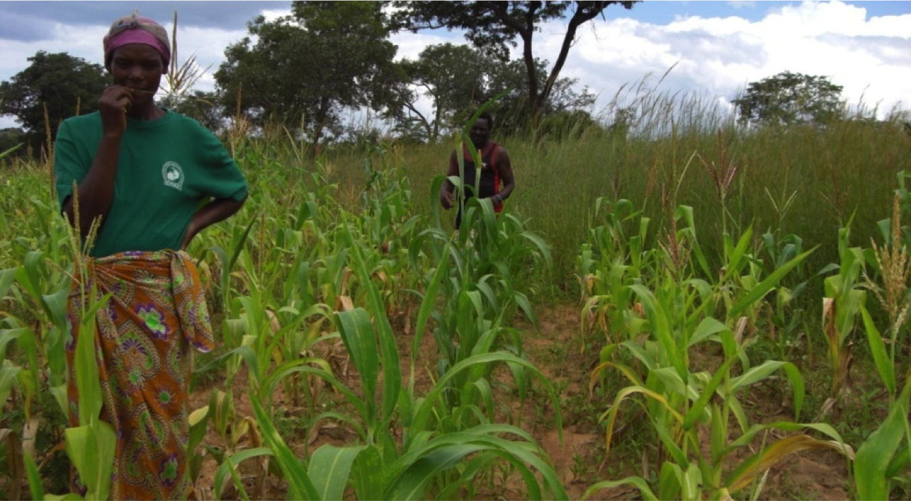 | Join us in learning about how climate change impacts food production worldwide with the UW-Madison MOOC “Climate Change Policy and Public Health” starting November 9th! We will be hosting discussion sessions {FILL IN DATE AND TIME} http://moocs.wisc.edu/
Post #6  Post date:  Week of 10/26 | 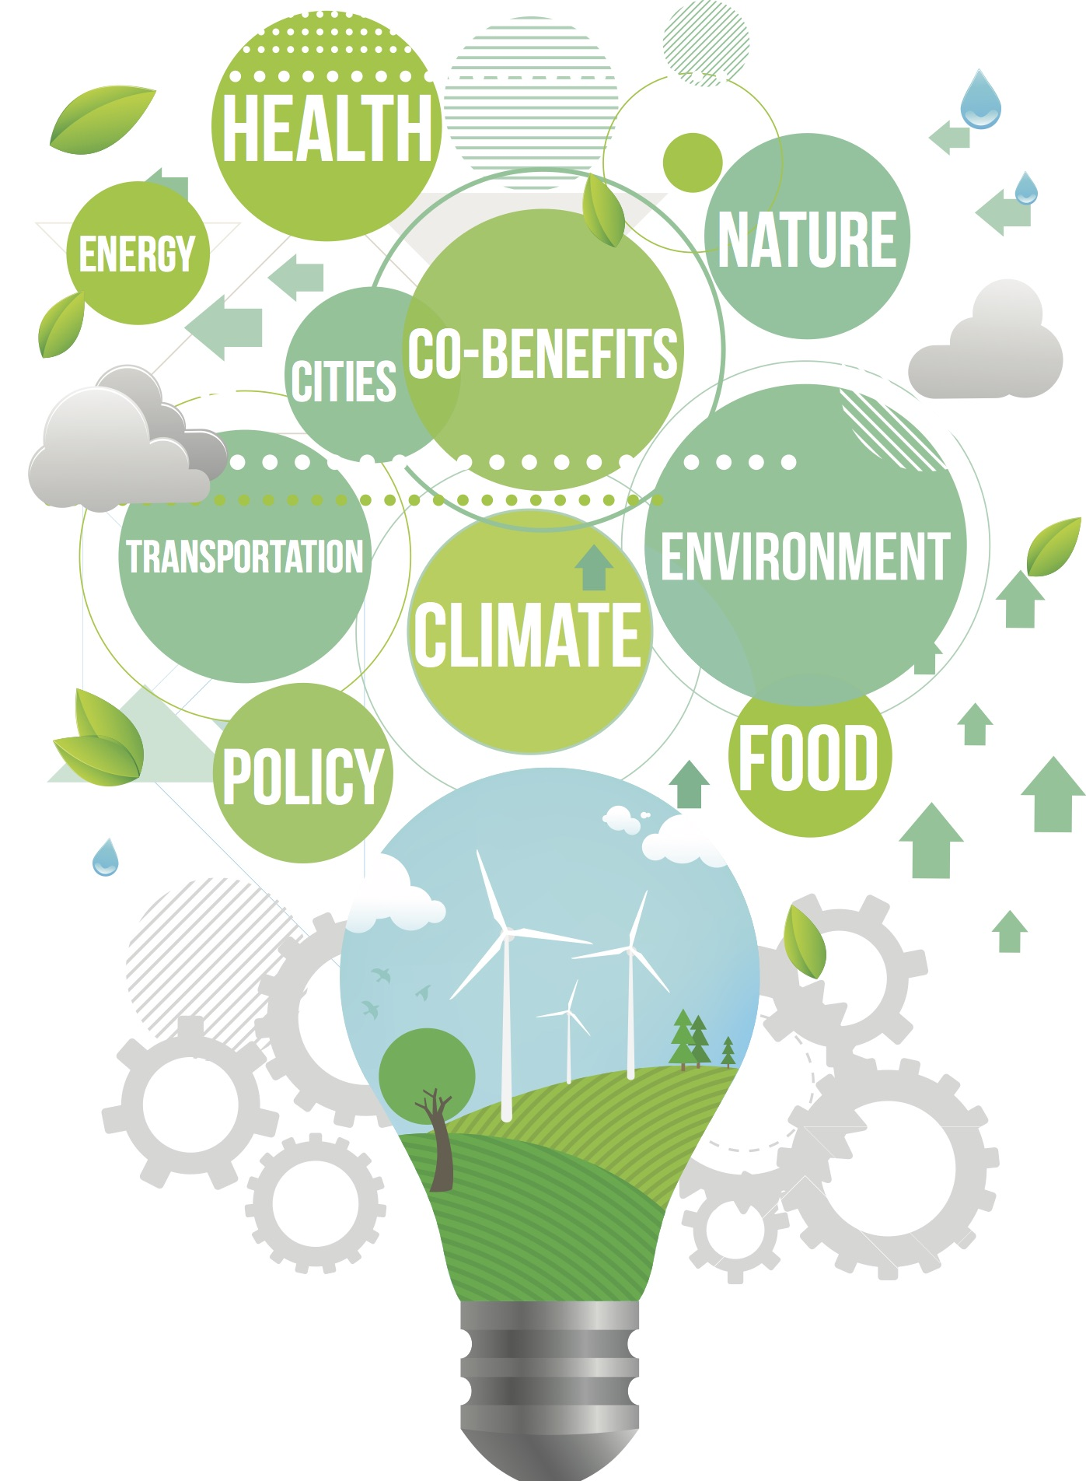 | Learn about practical solutions to make our climate safe and bodies healthy in the UW-Madison MOOC “Climate Change Policy and Public Health” starting November 9th! We will be hosting discussion sessions {FILL IN DATE AND TIME} http://moocs.wisc.edu/
Post #7  Post date:  Week of 11/2 |  | Starting NEXT WEEK, join a conversation about the relationship between protecting the climate and global health in the UW-Madison MOOC “Climate Change Policy and Public Health”! Enroll now to ensure you don’t miss a thing! We will be hosting discussion sessions {FILL IN DATE AND TIME} http://moocs.wisc.edu/
Post #8  Post date:  Week of 11/9  FIRST WEEK OF COURSE!! | <CCP & PH intro video – link will be on site soon:  https://moocs.wisc.edu/mooc/climate-change-policy-and-public-health/> | Join us as we kick off the UW-Madison MOOC “Climate Change Policy and Public Health” THIS WEEK! Learn about how climate change impacts our health in the United States and around the world. There’s still time to sign up! We are hosting discussion sessions {FILL IN DATE AND TIME} http://moocs.wisc.edu/
Post #9  Post Date: Week of 11/16 |  | What percentage of rural Indian households now have access to electricity (for at least part of the day)? Answer: two-thirds. Surprised? Join the UW-Madison MOOC “Climate Change Policy and Public Health” happening now to learn more! We are hosting discussion sessions {FILL IN DATE AND TIME} http://moocs.wisc.edu/
Post #10  Post date:  Week of 11/23 | 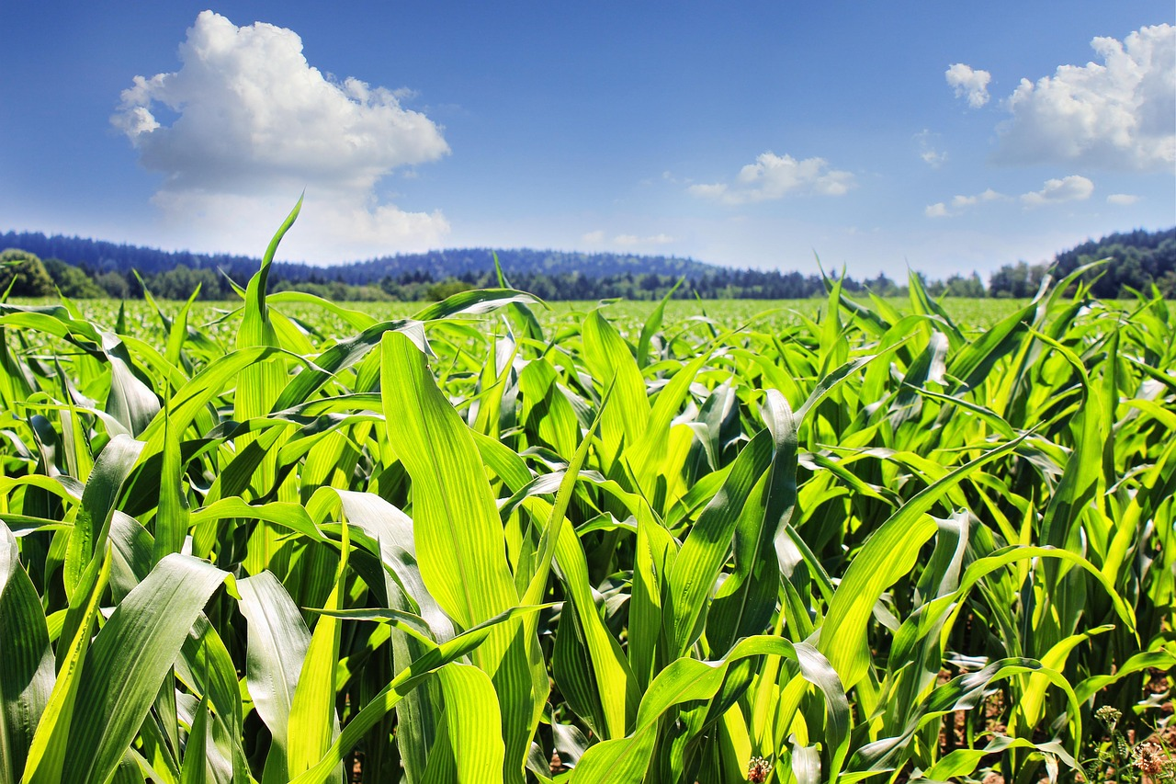 | The world has over 50 000 edible plants. Just three of them, rice, maize and wheat, provide 60 percent of the world's food energy intake (FAO, 2002). Join the conversation already in progress on the UW-Madison MOOC “Climate Change Policy and Public Health”! We are hosting discussion sessions {FILL IN DATE AND TIME} http://moocs.wisc.edu/
Post #11  Post date:  Week of 11/30 | 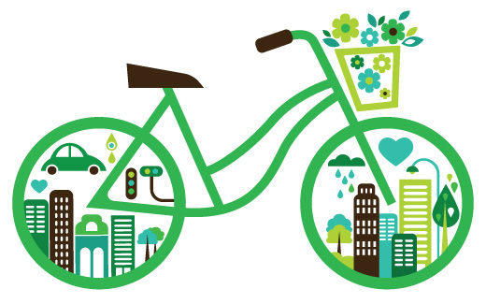 | What reduces your risk of chronic disease, improves your mental health, and decreases air pollution all at the same time? Riding a bike. Join the conversation already in progress on the UW-Madison MOOC “Climate Change Policy and Public Health”! We are hosting discussion sessions {FILL IN DATE AND TIME} http://moocs.wisc.edu/
Post #13  Post date:  Week of 12/7 |  | Thank you so much for participating in the UW-Madison MOOC “Climate Change Policy and Public Health”! We’ve enjoyed the conversation and are so happy you chose to engage with us on this topic. http://moocs.wisc.edu/

Twitter Posts:

GENERAL FACTS:
Climate Change @uwmoocs FACT: World Food Program states the number of people affected by climate change disasters could hit 375 mil. a year!
Climate Change @uwmoocs FACT: CC can have serious health impacts such as heat stress — many deaths from heart diseases. Yikes! #gogreen
Climate Change @uwmoocs FACT: Climate change boosts the spread of pests that cause life threatening diseases like malaria, and Lyme disease.
Climate Change @uwmoocs: How big do you think your carbon footprint is? Follow this link to find out! http://goo.gl/NlKRF8
Climate Change @uwmoocs FACT: Here are some ways to reduce your carbon footprint, unplug your gadgets and stop buying packaged water!
Climate Change @uwmoocs FACT: There are many green startups that are focused on our future! Click to discover more. http://goo.gl/FB0dxb
RENEWABLE ENERGY FACTS:
Climate Change @uwmoocs FACT:Biomass is currently the largest U.S. renewable energy source providing electricity for 1.5 million homes.
Climate Change @UWMOOC FACT: One wind turbine can produce enough electricity to power up to 300 homes. #sustainable #renewable
Climate Change @UWMOOC FACT: Local solutions, like micro-grids running on solar power, give poor communities control over their own energy.
AGRICULTURE & FOOD FACTS:
Climate Change @UWMOOC FACT: Sorry, but…The production of a pound of cheese can produce 11 pounds or more of carbon dioxide. #waste #gogreen
Climate Change @UWMOOC FACT: In Africa, the number of coffee growing regions is predicted to fall from 65% to 100% as the climate warms.
Climate Change @UWMOOC FACT: Effectively using livestock waste and growing crop diversity could reduce climate change impacts on agriculture
Climate Change @uwmoocs: Hey @UWBusiness ! Investment banks are advising to go green. Clean energy investments have doubled since 2007!
URBAN DESIGN & ACTIVE TRASNPORT FACTS:
Climate Change @UWMOOC FACT: The design of cities creates unique micro-climates that affect variables including temperature and wind.

Climate Change @UWMOOC FACT: Although cities cover less than 2% of the earth’s surface, cities consume 78% of the world’s energy. #gogreen

